Task 1: ArrayList Program

Objective:
Store and manage a list of student names.
Example:
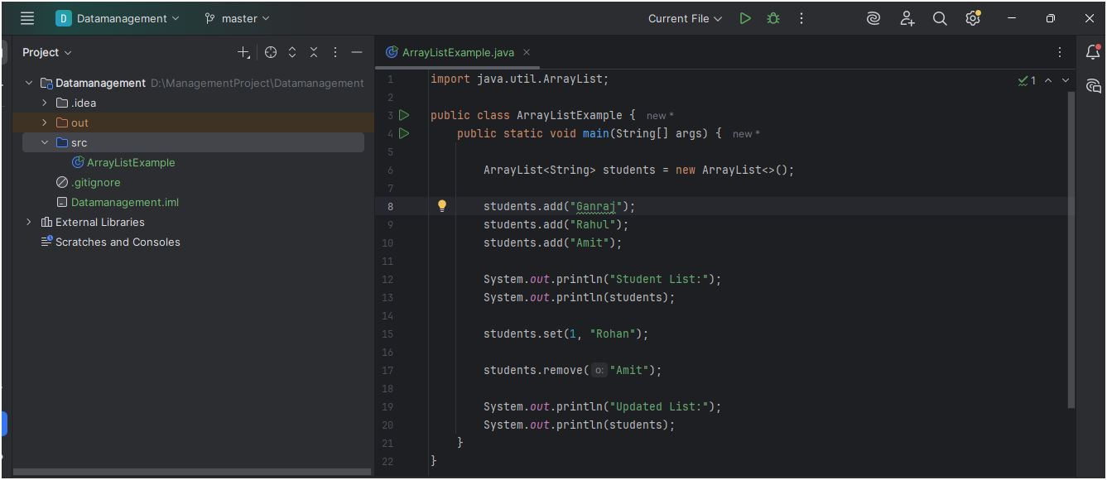
Output:
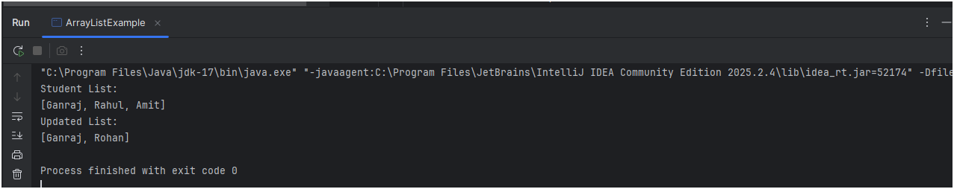

Task 2: HashMap Program
Objective:
Store Student ID and Student Name.

Example:
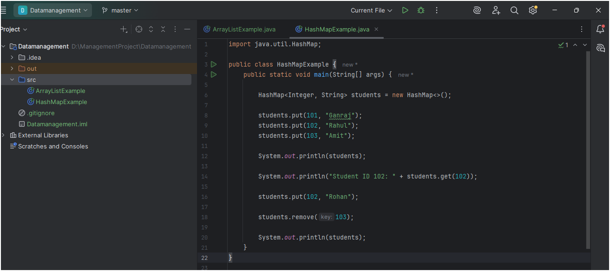
Output:
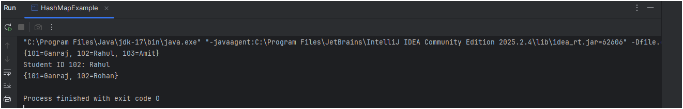

Task 3: HashSet Program
Objective
Show duplicate values are not stored.
Example:
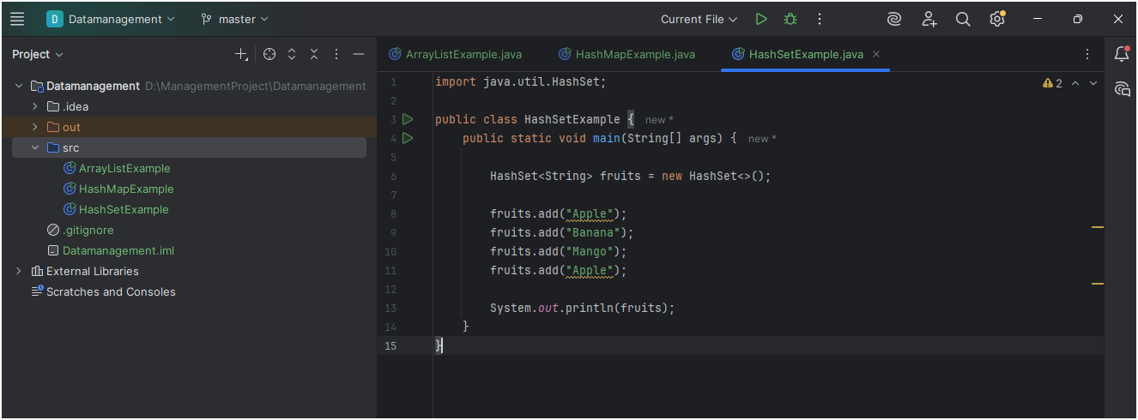
Output:
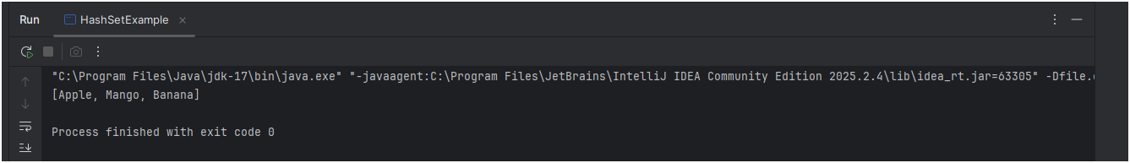

Task 4: Exception Handling
Objective
Handle runtime errors using try-catch.
Example: ArithmeticException
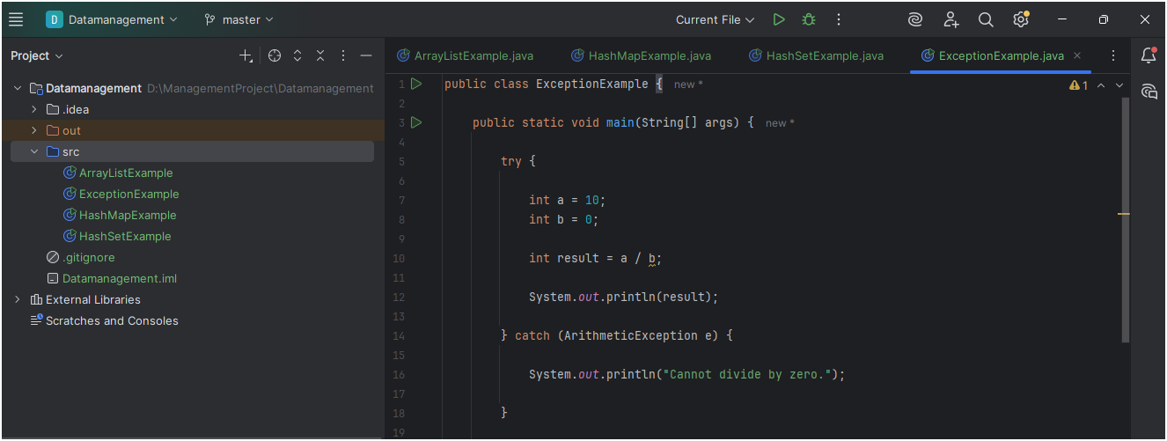
Output:
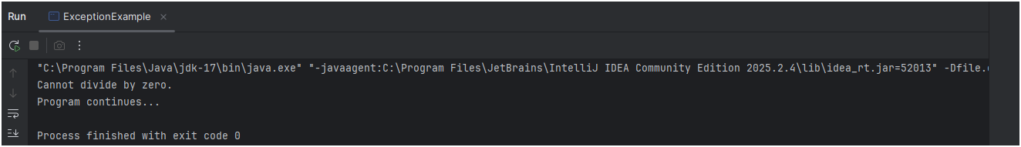
Example: ArrayIndexOutOfBoundsException
